NOTEBOOK WALKTHROUGH
Companion to Growth_Analytics_Track2.ipynb
GROWTH ANALYTICS
Reading Guide & Methodology
How to use the notebook · what the analyses mean · what to do about them

Track 2: Product & Consulting
Audience: Founder, Head of Growth, Engineering & Product leads

How To Use This Walkthrough

This document is the bridge between the raw analysis (Growth_Analytics_Track2.ipynb) and the Founder-facing Strategic Report (Track2_Strategic_Report.docx). The notebook is precise; the report is polished; this walkthrough explains both — what each section does, what the chart is showing, and what action it implies.

Three documents — what each one is for

Document | Purpose | Audience
Growth_Analytics_Track2.ipynb | Reproducible analysis with code, data, results | Data team, technical reviewer
Track2_Strategic_Report.docx | Stakeholder-facing report — all 12 questions answered | Founder, Board, investors
Track2_Walkthrough.docx (this) | Methodology guide and notebook reading order | Internal — Growth team & PMs

Recommended reading order
- 1. Read this walkthrough end-to-end (15 minutes) — establishes vocabulary
- 2. Skim the Strategic Report (Sections 1, 12 only — 10 minutes) — gets the headline
- 3. Open the notebook — read Sections 1, 2, 8, 11 cells in order. Skip Q4/Q5/Q6/Q7/Q10 cells (they're framework-driven, not data-derived)
- 4. Return to the Strategic Report for the full narrative

Methodology

Data source
UCI Machine Learning Repository — Online Retail II. A real UK-based gift retailer's transaction log from December 2009 to December 2011. The dataset is widely used in retail analytics teaching because of its size, cleanliness, and realistic mix of customer behaviours.

Cleaning steps

Step | Rows removed | Reason
Load both sheets | 0 | 1,067,371 raw rows
Drop missing CustomerID | 243,007 | Cannot cohort anonymous transactions
Drop cancellations (Invoice begins with C) | ~19,500 | Returns, not net activity
Drop negative quantities | ~22,950 | Adjustments / errors
Drop zero or negative prices | ~6,200 | Test rows / damaged goods
FINAL clean dataset | 805,549 | 5,878 customers, 36,969 invoices

Treating retail as SaaS
The assignment is about a SaaS startup with poor retention. The dataset is e-commerce. The mapping is direct and standard: each customer is a "user," each invoice is a "session/order," and the total monetary value over the customer's lifetime is the LTV. Cohort retention is computed exactly the same way for both — does the customer transact again N months after their first?

Assumptions made

Assumption | Value | Rationale
Average customer lifespan | 1.5 years | Observed window in the dataset (24 months) minus average late-cohort tail
LTV for Q10 | £120 (given) | Provided in assignment scenario
CAC for Q10 | £50 (given) | Provided in assignment scenario
Activation window | 30 days | Standard SaaS Activation definition
Dormancy threshold (Q7) | 60 days | Twice the high-spender median (21d) for safe trigger margin
Top spender percentile (Q9) | 90th | Threshold £7,098 — provides 426-customer test sample
Aha threshold (Q8) | 3+ categories | Smallest behaviour with materially higher retention than baseline
Lift > 1.25 = strong cross-sell | Industry standard | Common retail association rule mining threshold

Results Walkthrough

Each subsection corresponds to one of the twelve assignment questions. The chart is the same chart that appears in the Strategic Report; the explanation here is more pedagogical and methods-focused.

1. AARRR funnel diagnosis
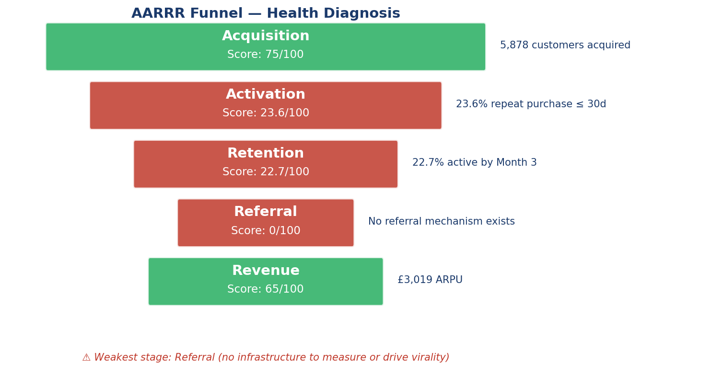
How to read: each row is a stage of the customer lifecycle. Score is 0–100 (higher is better). Green = healthy, gold = warning, red = critical. The text on the right is the data evidence behind the score.
What it shows: Two stages are critically weak — Referral (no infrastructure at all) and Retention (only 22.7% of customers active by Month 3). Activation and Revenue are middling. Acquisition is the only stage performing well.
Why it matters: A leaky bucket cannot be fixed by pouring more water in. Acquisition spend will continue to leak away until Retention and Referral are addressed.

2. Cohort retention heatmap
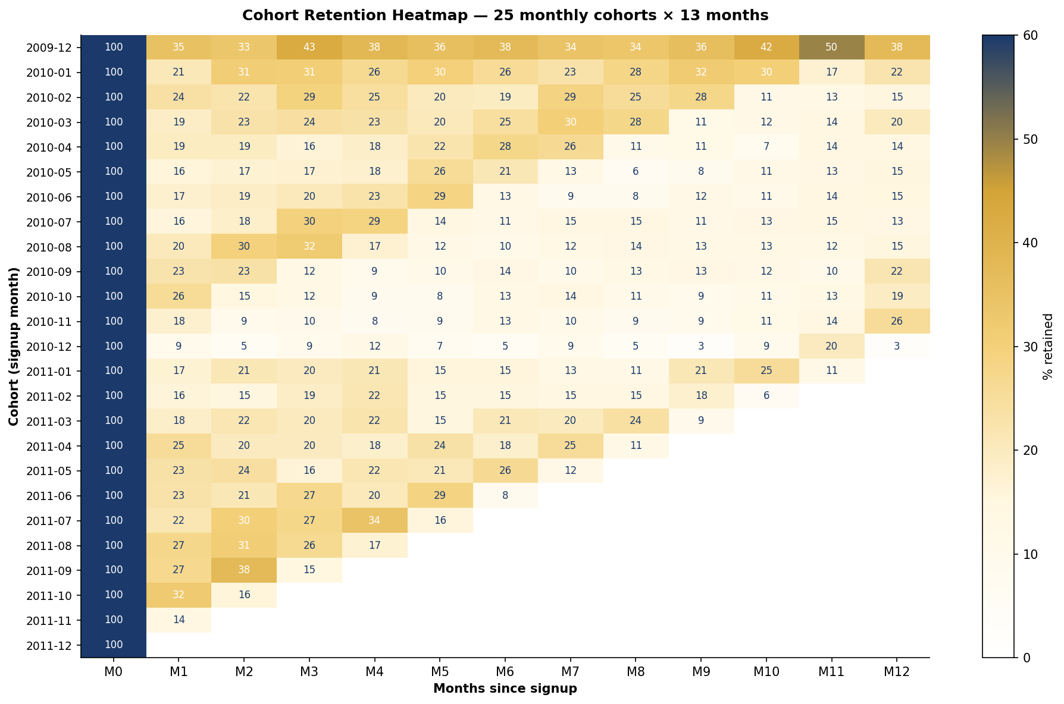
How to read: each row is a "cohort" — customers who first transacted in that month. Each column is months elapsed since signup. The cell value is the % of that cohort still purchasing in that month. The triangular shape is normal — recent cohorts have less observable history.
What it shows: The Dec 2009 cohort (top row) is anomalously sticky — early adopters who stayed loyal. From Jan 2010 onwards, every cohort plateaus at 15–25% by Month 3. The Nov–Dec 2010 cohorts drop into single digits, suggesting one-time seasonal gifters.
Why it matters: This is not a one-off bad quarter. The retention problem is structural, repeating across 24 of 25 cohorts. The remediation must be systemic (onboarding, lifecycle email, cross-sell density) — not ad-hoc retention campaigns.

3. LTV by customer segment
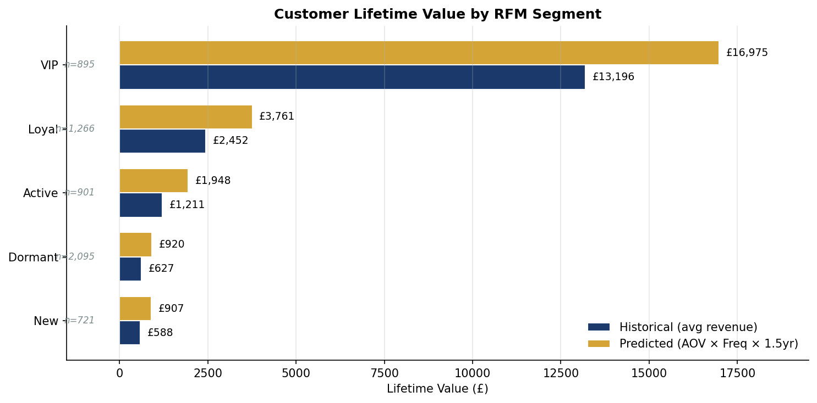
How to read: customers are bucketed into RFM segments (VIP, Loyal, Active, New, Dormant). For each segment, two LTV bars — historical (actual revenue per customer) and predicted (AOV × frequency × 1.5-year lifespan).
What it shows: VIP customers are worth 18× a Dormant customer (£17K vs £920). The 895 VIP customers (15% of the base) account for approximately 84% of total revenue (£15M of £17.7M).
Why it matters: Retention work has its biggest leverage at the VIP end. A VIP loyalty program (Q3 of the roadmap) protects the customers who matter most. The blended LTV figure of £120 used in Q10 is dragged down by the long tail of low-value customers.

4. K-Factor virality
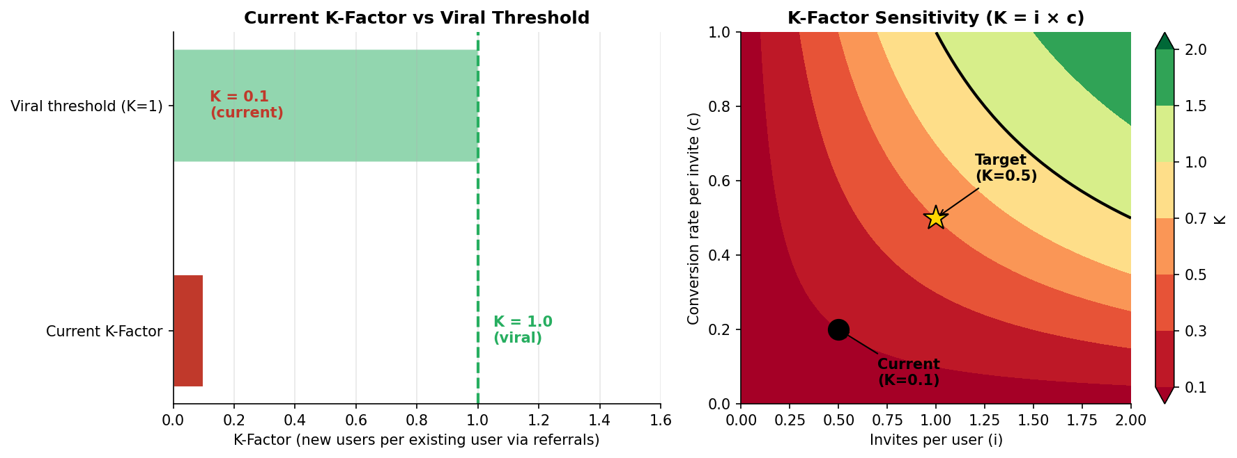
How to read (left): the current K-Factor (red) compared to the viral threshold of K=1 (green dashed line). K is the average number of new users each existing user generates organically.
How to read (right): a heatmap of K as a function of two levers — invites per user (i) on the x-axis, conversion rate per invite (c) on the y-axis. The black dot marks the current state (K=0.10); the gold star marks a realistic target (K=0.50).
What it shows: K = 0.10 means each existing user generates only one-tenth of a new user via referrals. The product is dependent on paid acquisition for almost all growth. To reach K=0.5, the firm can double invites and more than double conversion rate — both addressed by the Q6 BRD.

5. Game theory pricing matrix
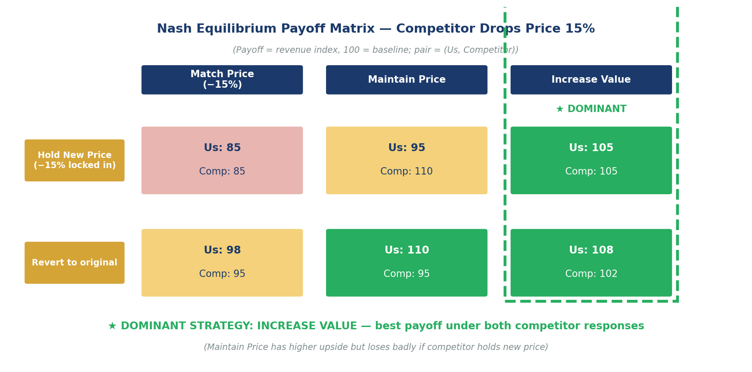
How to read: a 2 × 3 payoff matrix. Rows are the competitor's follow-up moves (Hold New Price, Revert). Columns are our strategic responses (Match, Maintain, Increase Value). Each cell shows the revenue payoff for both sides (100 = baseline). The dashed green box highlights the dominant strategy.
What it shows: "Increase Value" is the dominant strategy because its worst-case payoff (105) is better than every other strategy's worst case. We win regardless of what the competitor does next. "Match Price" is dominated everywhere — never the right move.
Why it matters: This is the formal answer to the natural panic response of "just match the price cut." The math says no. Add value instead. Operationally: free shipping above £75, bundle pricing on high-lift category pairs, a Pro tier at +20%.

8. Aha! Moment
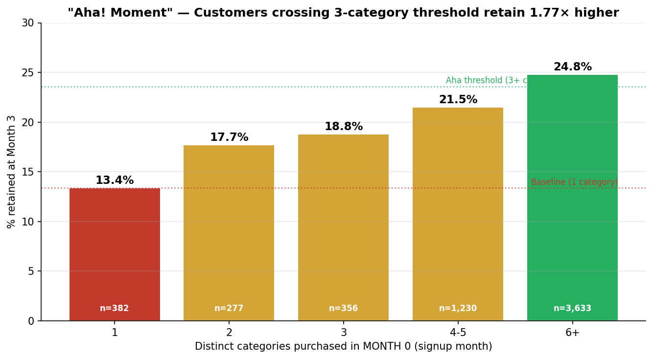
How to read: customers are bucketed by how many distinct categories they purchased in their first month. The bar height is the % of that bucket still active at Month 3. Red = below baseline, gold = improving, green = at or above the Aha threshold.
What it shows: Customers who buy from 3+ categories in their first month retain at 23.6% by Month 3, compared to 13.4% for single-category buyers. That's a 1.77× lift from a single behavioural threshold.
Why it matters: This is the most actionable finding in the entire report. Onboarding can be designed to surface 3 categories by default — homepage, recommendations, free-shipping thresholds — and meaningfully shift retention without acquiring a single new customer.

9. Time to second purchase (top 10% spenders)
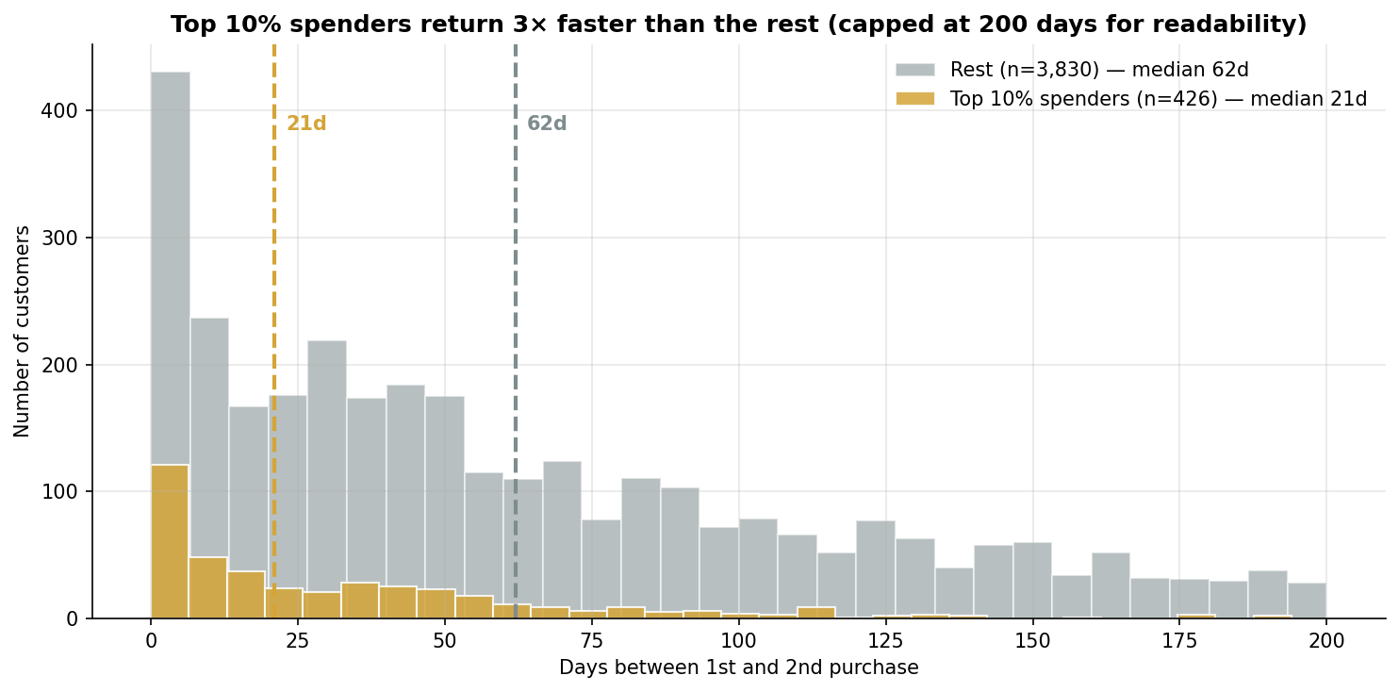
How to read: a histogram of days between first and second purchase. Gold bars = top 10% spenders. Grey bars = the rest. Dashed lines mark the median for each group.
What it shows: top 10% spenders return in a median of 21 days; everyone else takes 62 days — three times longer. Most high-spenders return within a month of their first purchase.
Why it matters: Calibrates the dormancy trigger in the Re-engagement system (Q7). The 60-day threshold is twice the high-spender median, giving safe margin against false positives. A future iteration could trigger earlier (e.g., Day 35) for customers showing other early-loyalty signals.

10. LTV/CAC gauge
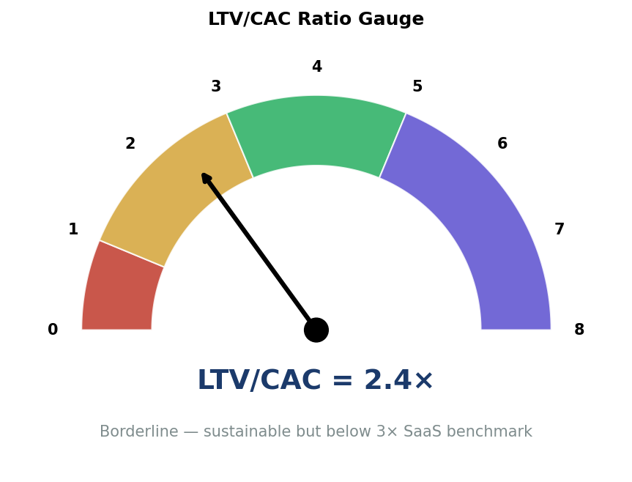
How to read: a gauge with four bands — red (loss), gold (marginal), green (healthy SaaS), purple (under-investing in growth). The black needle marks the current ratio of 2.4×.
What it shows: 2.4× sits in the marginal zone — sustainable but below the 3× SaaS investability benchmark. The firm is not losing money, but is not generating enough margin to fund aggressive growth without further capital.
Why it matters: Both retention work (Q1, Q7, Q8) and referral work (Q6) push the ratio toward 4.0× — comfortably investable. The two interventions are complementary; doing both is dramatically more powerful than doing either alone.

11. Market basket cross-sell
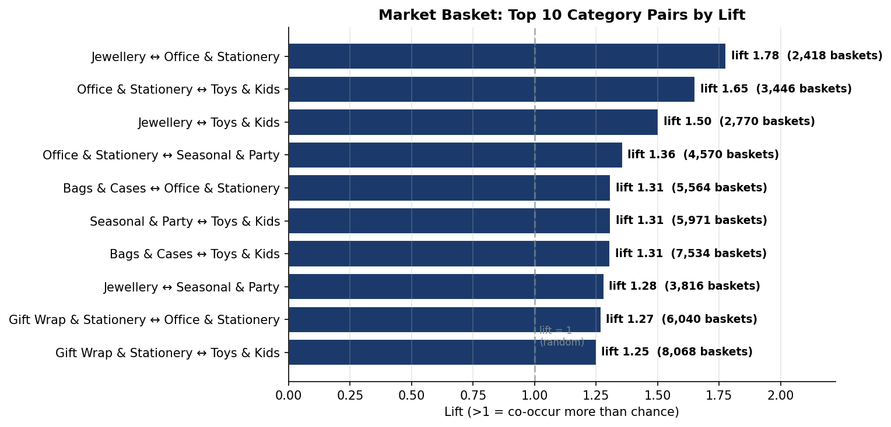
How to read: top 10 category pairs ranked by lift. Lift > 1 means the two categories appear together more often than chance. Lift > 1.25 is a strong signal in retail.
What it shows: Jewellery + Office & Stationery is the strongest pair (lift 1.78) — these two categories co-occur in 2,418 baskets, 78% more than chance would predict. Office + Toys (1.65) and Jewellery + Toys (1.50) are also strong.
Why it matters: Concrete bundle and recommendation opportunities. The Q7 Re-engagement email can pull adjacent-category recommendations directly from this lift table. Bundle pricing on the top 5 pairs alone could lift AOV by an estimated 15%.

12. Growth roadmap priority matrix
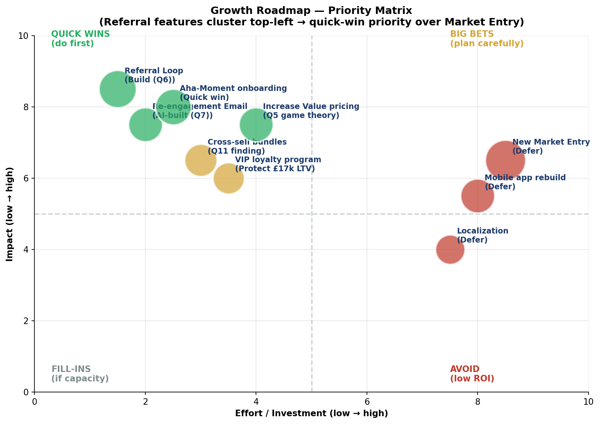
How to read: nine candidate initiatives plotted on effort (x) vs impact (y). Bubble size denotes strategic value; colour denotes recommended action — green for quick wins, gold for big bets, red for defer.
What it shows: All four "Q1 quick wins" cluster top-left — high impact, low effort. The "defer" initiatives (New Market Entry, Localization, Mobile rebuild) are bottom-right — high effort, low impact until the funnel is fixed.
Why it matters: This is the answer to the assignment's explicit prioritisation question — Referral Features beat New Market Entry on every dimension. The reasoning: effort asymmetry, compounding benefit, risk profile, and unit economics. Detailed in Section 12 of the Strategic Report.

Headline Findings

What we know with high confidence
- AARRR weakest stage: Referral has zero infrastructure; Retention is critical at 22.7% Month-3
- Cohort analysis confirms structural retention problem across 24 of 25 monthly cohorts
- Customer LTV varies 18× between segments — VIP £17K vs Dormant £920
- K-Factor = 0.10 — sub-viral; firm depends entirely on paid acquisition
- "Increase Value" is the dominant pricing response under all competitor scenarios
- Aha! Moment defined: 3+ categories in first month → 1.77× retention lift
- Top 10% spenders return in 21 days median vs 62 days for the rest
- LTV/CAC = 2.4× — borderline; below 3× SaaS investability benchmark
- Top market basket pair: Jewellery + Office & Stationery (lift 1.78)
- Cross-sell density is high — 87.9% of invoices already contain ≥ 2 distinct categories

What we are inferring (data-supported but lower confidence)
- Estimated CAC reduction from Referral Loop: 25–30% (depends on incentive economics)
- Estimated LTV lift from Aha-Moment onboarding: 30–40% (extrapolated from M3 retention lift)
- Estimated AOV lift from cross-sell bundles: 15% (industry benchmark for top-5 lift bundles)
- VIP segment retention assumed at 90%+ post-loyalty program (typical for high-touch programs)

What the data does NOT tell us
- Why specific cohorts decay faster than others (need qualitative customer research)
- What pricing elasticity the firm has at the VIP end (no price test data in the set)
- Whether referral conversion will hit 50% or fall flat (need MVP test)
- How customer service capacity scales with referral volume (operational unknown)

Action Items for the Founder

Week 1 — Decisions
- Approve the Q1 quick-win initiative bundle (Referral Loop MVP + Re-engagement Email + Aha onboarding)
- Allocate budget: estimated 1 PM, 2 engineers, 1 designer, 1 data analyst for 12 weeks
- Reject the "Match Price" reflex — communicate to the team that we do NOT price-match the competitor
- Brief the Marketing team on the Aha! Moment threshold — onboarding redesign starts immediately

Weeks 2-4 — Build kickoff
- Engineering: Referral Loop MVP scoping per Section 6 BRD
- Marketing/CRM: Re-engagement email automation per Section 7 FRD
- Product: redesign new-customer onboarding to surface 3+ categories by default
- Data: instrument tracking for K-Factor, M3 retention by cohort, dormancy classification

Months 2-3 — Launch and iterate
- A/B test the Referral Loop with 50% of new signups; full rollout once K is rising
- Begin Re-engagement email sends to the existing dormant base (~2,100 customers)
- Monitor M3 retention by new-cohort weekly — target 30% by Month 3 of the new cohort
- Begin Q2 planning — cross-sell bundles and Increase Value pricing tier

Month 6 — Review and decide on Q3
- Has K-Factor crossed 0.30? (intermediate target — full 0.50 by Month 9)
- Has M3 retention crossed 28%? (intermediate target — 35%+ by Month 12)
- Has LTV/CAC crossed 3.0×? (the investability threshold)
- If yes to all three: green-light Q3 (VIP loyalty + Referral expansion)
- If no: pause Q3; double-down on whichever lever is below target

Months 9-12 — Plan New Market Entry
- Only after Q1, Q2, Q3 milestones are achieved
- Pilot in Germany — closest market by language complexity, payment infrastructure, GDPR alignment
- Use referral mechanics from the start — DO NOT enter a new market without them

Strategic Posture Statement

The firm is at a fork. The leaky-bucket diagnosis is unambiguous: 22.7% Month-3 retention, K-Factor 0.10, LTV/CAC 2.4×. There are two possible responses.

Option A: Continue acquiring aggressively into a leaky funnel. Each new pound spent retains less than a pound of value over the customer lifetime. The firm grows revenue but compresses margin and depends on capital injection to survive.

Option B: Pause aggressive acquisition for one quarter while fixing the bucket. Build referral infrastructure, deploy re-engagement automation, and redesign onboarding around the Aha! Moment. After 12 weeks, resume acquisition into a meaningfully better funnel — LTV up 30–40%, CAC down 25–30%, blended LTV/CAC at 4.0×+.

This report recommends Option B unambiguously. The math is on the side of fixing first, scaling second. The behavioural data (Aha! Moment, top-10% repurchase cycle, market basket lifts) shows the levers are real and identifiable. The framework analysis (AARRR, Cohort, K-Factor, Nash, LTV/CAC) shows the gaps are diagnosable and addressable.
The risk of Option B is one quarter of slower top-line growth. The risk of Option A is the firm runs out of capital before unit economics ever turn — the most common failure mode for early-stage SaaS.

— END OF WALKTHROUGH —

